Customization -> Scripting -> Script debugger;
The idea would be that from NSPOS we press a button, that will call ERP, then ERP will call Zinrelo. Then create a restlet with 3 functions inside:
- Create loyalty member (I have to create it)
- Get eligible rewards (Mat)
- Load loyalty points from customer and
Documentation for the API: https://help.zinrelo.com/reference/authentication
For authentication, I can use the code on mat’s example:
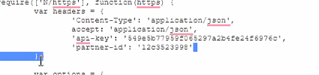
Api-key should be encrypted
require(['N/https'], function(https) {
var headers = {
'Content-Type': 'application/json',
accept: 'application/json',
'api-key': '549e5b77959f065297a2b4fe24f6976c',
'partner-id': '12c3523998'
};

var options = {
url: 'https://api.zinrelo.com/v2/loyalty/members/mat%40mat.com?idParam=member_id',
method: https.Method.GET,
headers: headers
};

var response = https.request(options);

if (response.code === 200) {
var body = response.body;
// Do something with the response body
log.debug({
title: 'Debug Entry',
details: body
});
} else {
throw new Error('Error: ' + response.code + ' ' + response.body);
}
});
Modify the script debugger and add my function.
All this does calls to Zinrelo with my mail: This is executed on ERP and will be called by a button in NSPOS

